Name___________________________________

Quick Quiz

**Unit Rate 12**

Identify the unit rate:

1. temperature dropped 27° in 3 days 2.

**_________ degrees per day unit rate =_________**

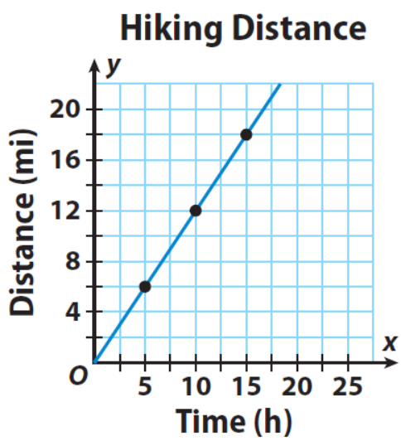

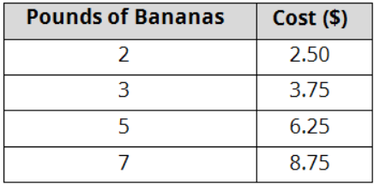

3. 4.

**________**

**miles per hour**

**$_________ per banana**

____________________________________________________________________________

Corrections

**Unit Rate 12**

Identify the unit rate:

1. temperature dropped 27° in 3 days 2.

**_________ degrees per day unit rate =_________**





3. 4.

**________**

**miles per hour**

**$_________ per banana**